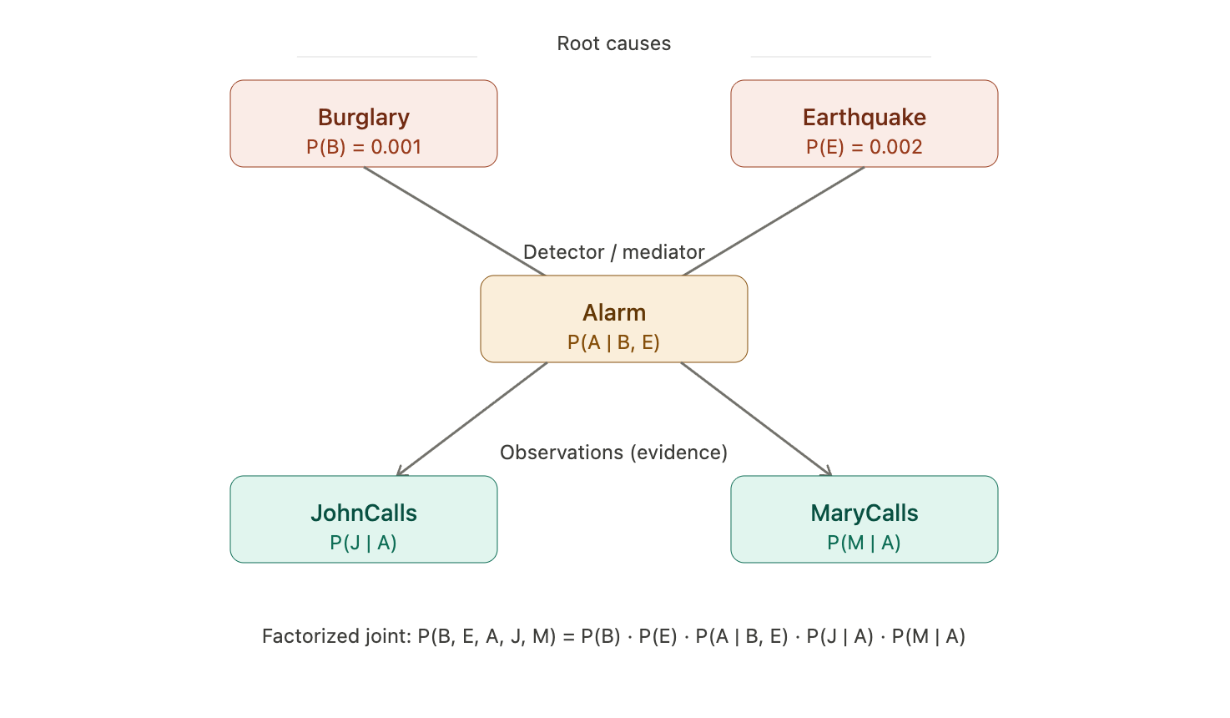
Burglary and Earthquake are the primary ways to trigger an alarm.

Once the alarm is triggered, John or Mary calls the police

Are Bayesian networks discriminative or generative?

from transformers import AutoModelForCausalLM, AutoTokenizer
import torch

model_name = "distilgpt2" #distilgpt2: a smaller and faster version of GPT-2

# Load the tokenizer used by the model
tokenizer = AutoTokenizer.from_pretrained(model_name)
print(f"Vocabulary size of {model_name} = {tokenizer.vocab_size}")
# Set the prompt
prompt_text = "Though Fullerton is the largest city in the state of"

# Use the tokenizer to convert the prompt to tokens
inputs = tokenizer(prompt_text, return_tensors="pt")

# The 'input_ids' are the integer ids of the tokens
print("Prompt text:", prompt_text)
print("Token IDs:", inputs["input_ids"])

# Decode each token ID back to its string representation
tokens = [tokenizer.decode(token_id) for token_id in inputs["input_ids"][0].tolist()]
print("Tokens:", tokens)
Prompt text: Though Fullerton is the largest city in the state of
Token IDs: tensor([[10915, 6462, 29111, 318, 262, 4387, 1748, 287, 262, 1181,
286]])
Tokens: ['Though', ' Full', 'erton', ' is', ' the', ' largest', ' city', ' in', ' the', ' state', ' of']
# Load the model
from transformers import AutoModelForCausalLM, AutoTokenizer
model = AutoModelForCausalLM.from_pretrained(model_name)
Loading weights: 100%
76/76 [00:00<00:00, 288.38it/s, Materializing param=transformer.wte.weight]
GPT2LMHeadModel LOAD REPORT from: distilgpt2
Key | Status | |
-------------------------------------------+------------+--+-
transformer.h.{0, 1, 2, 3, 4, 5}.attn.bias | UNEXPECTED | |

Notes:
- UNEXPECTED :can be ignored when loading from different task/architecture; not ok if you expect identical arch.
with torch.no_grad(): # disable gradient calculations as we are not training the model

outputs = model(inputs["input_ids"]) # Get the model output in logits

next_token_logits = outputs.logits[:, -1, :] # get the logits for only the last token in the input sequence

# Convert logits into probabilities using the softmax function
probabilities = torch.nn.functional.softmax(next_token_logits, dim=-1)

# Find the token ID with the highest probability
most_likely_next_token_id = torch.argmax(probabilities).item()

print(f"The most likely next token's id is: {most_likely_next_token_id}")
print(f"This token is: '{tokenizer.decode(most_likely_next_token_id)}'")
print(f"Highest probability is: '{torch.max(probabilities)}'")
The most likely next token's id is: 3442
This token is: ' California'
Highest probability is: '0.7623555064201355'
# generate tokens one after the other in a loop
generated_ids = inputs["input_ids"]

print("Starting prompt tokens:")
print(tokenizer.decode(generated_ids[0]))

# Generate 5 tokens, one token at a time
for _ in range(15):
with torch.no_grad():
outputs = model(generated_ids)
next_token_logits = outputs.logits[:, -1, :]
next_token_id = torch.argmax(next_token_logits, dim=-1).unsqueeze(-1) # convert to tensor

# Append the predicted token_id to input sequence
generated_ids = torch.cat([generated_ids, next_token_id], dim=-1)

# Print the generated token
print(tokenizer.decode(next_token_id[0]), end="")
Starting prompt tokens:
Though Fullerton is the largest city in the state of
California, with a population of more than 1,000.

# generate multiple tokens using the built-in generate()
output_ids = model.generate(
**inputs, max_length=50, pad_token_id=tokenizer.eos_token_id # EOS: End-of-Sequence
)

# Decode the entire sequence of token IDs into a single string
generated_text = tokenizer.decode(output_ids[0])

print("Generated text:")
print(generated_text)
Generated text:
Though Fullerton is the largest city in the state of California, with a population of more than 1,000.

